**PRE LAB 3**

**Exercise 1**

library ieee;

use ieee.std_logic_1164.all;

use ieee.std_logic_unsigned.all;

use ieee.numeric_std.all;

use ieee.std_logic_arith.all;

entity PreLab3Ex1 is

    port(a:      in  std_logic_vector(7 downto 0);

         b:      in  std_logic_vector(7 downto 0);

         result: out std_logic_vector(7 downto 0));

end PreLab3Ex1;

architecture eight_bit_adder of PreLab3Ex1 is

begin

    result <= a + b;

end eight_bit_adder;

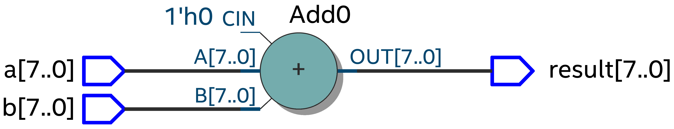

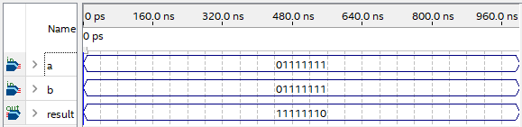

**Exercise 2**

library ieee;

use ieee.std_logic_1164.all;

use ieee.std_logic_unsigned.all;

use ieee.numeric_std.all;

use ieee.std_logic_arith.all;

entity PreLab3Ex2 is

    port(a:      in  std_logic_vector(7 downto 0);

         b:      in  std_logic_vector(7 downto 0);

         result: out std_logic_vector(15 downto 0));

end PreLab3Ex2;

architecture eight_bit_multiplier of PreLab3Ex2 is

begin

    result <= a * b;

end eight_bit_multiplier;



